|  |  |
| --- | --- |
| Assert Payload | This validates that the payload of a Mule message is equal to an expected value:  <munit:assert-payload-equals message="Failed!" expectedValue="#[10]" doc:name="Assert Payload"/> |
| Assert Null | This validates if the mule message payload is null. The only property that needs to be defined is the failure message. |
| Assert Not Null | This validates if the mule message payload is NOT null. The only property that needs to be defined is the failure message. |
| Assert Equals | This validates equality between the actual and expected values of the mule message. Both expected and actual values accept MEL expressions:  <munit:assert-on-equals message="Test Failed!!" expectedValue="#[&quot;2019&quot;]" actualValue="#[flowVars.Year]" doc:name="Assert Equals"/> |
| Assert Not Equals | This validates if the actual and expected values of the mule message are different. Both expected and actual values accept MEL expressions:  <munit:assert-not-same message="Test Failed!!"expectedValue="[&quot;2015&quot;]"actualValue="#[flowVars.Year]" doc:name="Assert Not Equals"/> |
| Assert True | This validates the expression provided in the condition evaluates to **True.** |
| Assert False | This validates the expression provided in the condition evaluates to **False.** |
| Fail | This is used when you want to fail any test on purpose. It may be required when you provide incorrect input to the test and want the Mule flow/sub-flow to fail. |

# Executing MUnit Tests

MUnit tests can be executed from inside Anypoint Studio, from the Maven command line, or configured for a build automation tool such as Jenkins.

## Executing MUnit Tests from Anypoint Studio

* + To run an entire MUnit test suite, right click on the MUnit canvas and select **Run MUnit Suite**
  + To run a specific MUnit test:> Right click on test > Select **Run MUnit test**
  + MUnit tests can be debugged using **Debug** option. While debugging, you can set breakpoints on the message processor in the MUnit test as well as your Mule flows/sub-flows
  + MUnit tests can be run from the MUnit tab as well. There is also an option to only run failed test cases.

The following tab will be generated once the MUnit test run is complete

If you run more than one test, the **MUnit** tab displays a history of run tests. The **Coverage** tab displays test coverage for each Mule flow/sub-flow as well as overall test coverage for your Mule project. For failed tests, the **Errors** tab displays the stack trace, which you can copy to your clipboard. To copy the stack trace, right-click the name of the failed test, then select **Copy Stack Trace**.

You can click the **Generate Report** button to get the report detailing the Mule flows/sub-flows and message processors contained by the Mule configuration files that were included in the MUnit test.

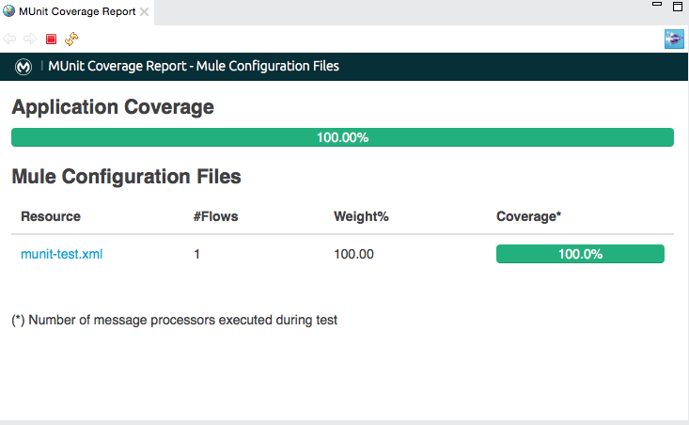

## Configuring MUnit for Maven

MUnit tests can be executed using a Maven plugin. This is useful for executing tests from the command prompt or from a continuous integration environment. In order to execute MUnit tests, you need to reference the MUnit Maven plugin in your POM file.

* + <MUnit.version> and <mule.MUnit.support.version> are mandatory in the POM file for MUnit. Please maintain the same version across all MUnit artifacts in the POM file.
  + **POM file plugins**

* + **POM file dependencies**

* + **MUnit Dynamic Ports:** When attempting to run MUnit tests in a continuous integration environment, your application may fail when attempting to open a specific port that may already be in use. To overcome this issue, Maven supports the use of dynamic ports. This feature instructs Mule to look for unbound ports between [40000] and [50000] and reserve them prior to executing the MUnit test. To enable the feature, you need to add the following setting to the configuration section of the MUnit Maven Plugin in your POM file:

<dynamicPorts>

<dynamicPort>http.port</dynamicPort>

</dynamicPorts>

Make sure your HTTP listener configuration binds to that port dynamically:

<http:listener-config name=”HTTP_Listener_Configuration” host=”0.0.0.0” port=”${http.port}”/>

* + **Setting System Variables:** Specific system variables can be set in the MUnit if the flow needs to access them. This is done inside MUnit plugin itself. System Property variables override any property set in the mule- app.properties file or with a property placeholder. You can override these variables using the -D argument when running MUnit with Maven. This takes full priority over any other property.

<configuration>

<systemPropertyVariables>

<my.property.key>my.property.value</my.property.key>

</systemPropertyVariables>

</configuration>

## Executing MUnit Tests via Maven

|  |  |
| --- | --- |
| mvn clean test | This command is used to run all MUnit tests. |
| mvn clean test - DMUnit.test=.*new-test.* | This command is used to run multiple tests in a singletest suite. Regular expressions are supported. |
| mvn clean test - DMUnit.test=.*new-test-suite.*#.*test-case1.* | This command is used to run a specific test from a given test suite. The test suite and test names are separated by a hashtag. Regular expressions are supported. |
| mvn clean test - DMUnit.test=.*hr-ben-005- test.* > result.txt | This command is used to write the test results to the file **results.txt**. This file will be present in the project root directory from where the MUnit test wasinitially run. |
| mvn clean package -DskipTests | This command is used to build a package, skipping all MUnit tests in the process. |

# Test Coverage

## Defining Test Coverage Metric

Test coverage is a metric used to describe the degree to which the source code of an application is executed when a particular set of tests are run. Since there is very little coding involved in building a flow, thetraditional lines of code (LOC) metric is NOT used. Instead, MUnit calculates coverage by counting all the event processors that have been executed as result of the MUnit test being run and compares that number with the total number of event processors that compose the entire application.The formula for test coverage is:

***Number of Components Executed / Total Number of Components***

As a general rule of thumb, each XML node inside a top-level XML node is considered an event processor (i.e. each node inside a flow, sub-flow, catch, batch).The following Mule flow has 7 totalcomponents:

**Note: The message source (HTTP) isNOT counted.**

## Test Coverage Reporting in Maven

Maven can be configured to generate a report which has test coverage details. To do this, add the following setting to your POM file:

This setting enables Test Coverage report generation in HTML format. A file called **summary.html** is generated in this folder: **${application.path}/target/munit-reports/coverage**. Additional Test Coverage report formats include **Console**and **JSON**.

**Sample Test Coverage HTML Report:**

**Sample Test Coverage JSON Report:**

{

"coverage": 75,

"requiredApplicationCoverage": 40,

"requiredResourceCoverage": 30,

"requiredFlowCoverage": 25,

"flowCount": 3,

"processorCount": 4,

"coveredProcessorCount": 4,

"files": [

{

"name": "file1.xml",

"flowCount": 1,

"coverage": 100,

"processorCount": 2,

"weight": 100,

"flows": [

{

"name": "file1Flow1",

"type": "FLOW",

"coverage": 100,

"processorCount": 2,

"coveredProcessorCount": 2

}

]

},

{

"coverage": 50,

"flowCount": 2,

"messageProcessorCount": 2,

"flows": [

{

"coverage": 0,

"messageProcessorCount": 1,

"name": "file2Flow1"

},

{

"coverage": 100,

"messageProcessorCount": 1,

"name": "file2Flow2"

}

],

"name": "file2.xml"

}

]

}

**Sample Test Coverage Console Report:**

**SureFire Reports:** By default, Maven generates Maven Surefire reports in **${project.build.directory}/surefire-reports.**

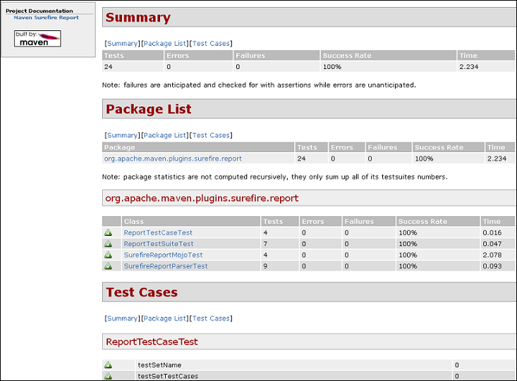

If these reports are NOT needed, you can disable them with this POM setting:

<enableSurefireReports>false</enableSurefireReports>

## Enforcing Test Coverage in Maven

We can also configure Mavento fail the build if a certain level of test coverage is NOT achieved:

If we define test coverage levels, but set the **failBuild**property to **false**, and if the levels are NOT reached, a warning shows up in the MUnit coverage summary report.

INFO] [CoverageManager] Printing Coverage Report...

[INFO] ===============================================================================

[INFO] MUnit Coverage Summary

[INFO] ===============================================================================

[INFO] * Resources: 3 - Flows: 6 - Message Processors: 7

[INFO] * Application Coverage: 71.43%

[NOTE]

[WARNING] ----------------------------- WARNING --------------------------------------

[WARNING] * Application coverage is below defined limit. Required: 100.0% - Current: 71.43%

Sometimes you may NOT want to include a specific Mule flow/sub-flow in your test coverage calculation, especially if you are still working on it. Excluding Mule flows/sub-flows from test coverage calculation can be done by adding the following setting to your POM file:

# MUnit Support for Domain Projects

If your Mule Application depends on a Mule Domain, there are a few considerations to take into account when using Maven projects.

1. **Artifact ID Must Match Folder Name**

The folder in your workspace containing your Mule project must have the same name as the artifact ID defined in your POM file. If your Mule project’s Artifact ID is:

<artifactId>mule-project</artifactId>

Then, the folder in your Studio workspace must be named **mule-project**.

1. **Install Your Domain in an .M2 repository**

When you mavenize your domain, you need to install the domain in a .M2 repository. This could be your local repository or it could be a repository that’s shared across your organization.

1. **Reference Your Domain in Test Suite POM File**

When mavenizing your Mule application, Studio automatically adds your mavenized domain to your Mule application’s POM file. If your Mule domain project looks like this:

<modelVersion>4.0.0</modelVersion>

<groupId>com.mulesoft</groupId>

<artifactId>domain-project</artifactId>

<packaging>mule-domain</packaging>

<version>1.0.0-SNAPSHOT</version>

<name>Domain domain-project Project</name>

Then the dependency in your Mule application should look like this:

<dependency>

<groupId>com.mulesoft</groupId>

<artifactId>domain-project</artifactId>

<version>1.0.0-SNAPSHOT</version>

<scope>test</scope>

<type>zip</type>

</dependency>

# Tips for Writing Great MUnit Tests

It’s easy to dismiss writing MUnit tests as a chore that’s needed to hit a certain threshold for code coverage. But by following some of these best practices and key principles, we can write high quality MUnit tests:

1. **Targeted:** MUnit tests that test one thing (including one set of inputs) at a time are considered targeted. Ideally, a MUnit test should examine one functionality of the Mule flow. This allows you to test the output of any piece of your Mule flow/sub-flow and see if it matches with expected output.
2. **Isolated:** The Mule flow/sub-flow you are testing should be isolated from other Mule flows/sub-flows in the application as well as any external dependencies or events.
3. **Repeatable & Predictable:** A MUnit test should be capable of being run over and over and assuming that the Mule flow/sub-flow and the test itself have NOT changed, the same results should be produced.
4. **Independent:** Your MUnit tests should never be dependent on each other. The order of execution should never matter and there should NOT be any assumption that your MUnit tests are going to run in any specific order.
5. **Mock out all external services/end-points:**MUnit tests should never be dependent on data from external services which may change. They are meant to test the functionality of your Mule flows/sub-flows and NOT the responses from external endpoints.
6. **Avoid unnecessary preconditions:**Avoid having common setup code that runs at the beginning of MUnit tests. Otherwise, it’s unclear what assumptions each test relies on, and indicates that you’re NOT testing just a single unit.
7. **Name your unit tests clearly and consistently:**Give a meaningful and business friendly name for each MUnit test in order to relate it to the functionality being tested. Also, adding a description and comments at the top of each testcase will help with code maintainability and enhancement support.
8. **Keep it Simple:**It’s also a good idea to implement simplicity in your development methodology. Readability and maintainability will make it easy for the person that takes over the tests after you, to jump in and make the changes. Readable tests can also serve as internal documentation for your feature.

# Summary of Best Practices

This section summarizes some of the best practices for implementing MUnit testing at your organization

* **Start MUnit Early:**MUnit tests should be written as part of the development process and should be consideredwhen providing development estimates. It is much easier to develop MUnit tests during development rather than adding it after development is complete. Retroactively adding MUnit tests often requires refactoring your Mule flows to conform to some of the best practices discussed in previous sections.
* **Enforce Test Coverage:** Test coverage should be enforced in your POM file. While it’s NOT reasonable to expect 100% test coverage, we should have minimum thresholds for test coverage:

|  |  |  |  |  |
| --- | --- | --- | --- | --- |
| **runCoverage** | **failBuild** | **requiredApplicationCoverage** | **requiredResourceCoverage** | **requiredFlowCoverage** |
| true | true | 85 | 85 | 85 |

* **Code Checklist:** MUnit test cases should be part of any code review and code check list. Developers should NOT deploy to the DEV environment until MUnit test cases have been developed and reviewed.
* **Focus on Test Quality:** Test coverage is only a metric. It is possible to have adequate or even 100% test coverage and still have gaps in unit testing.

By writing two MUnit test cases that set the payload to either 2 and 5, we are able to hit 100% test coverage since we covered both branches in the choice router. **However, our MUnit testing did NOT account for a null payload.**